**QUERY TEST**

**SUBQUERY:**

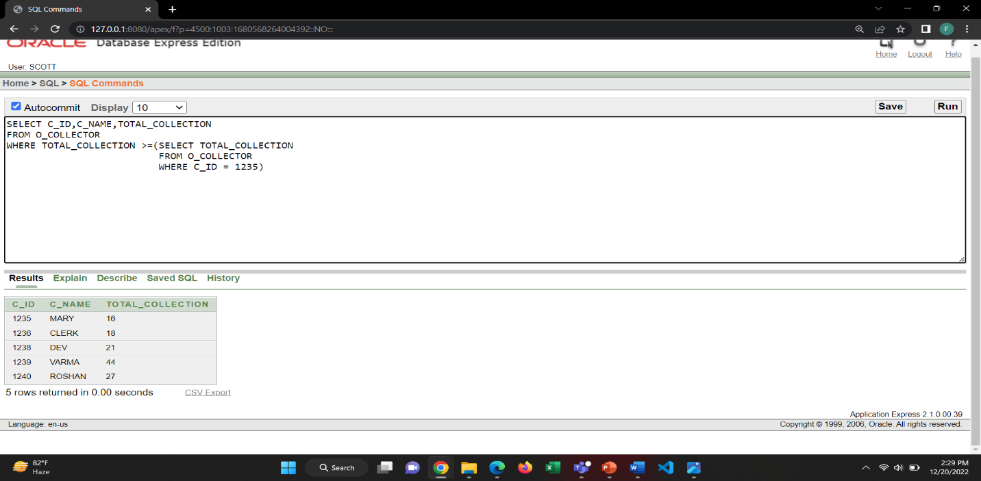1. Show the Collector Name, Collector ID, Total Collection of those collector, whose collection is greater than the collector with ID = 1235

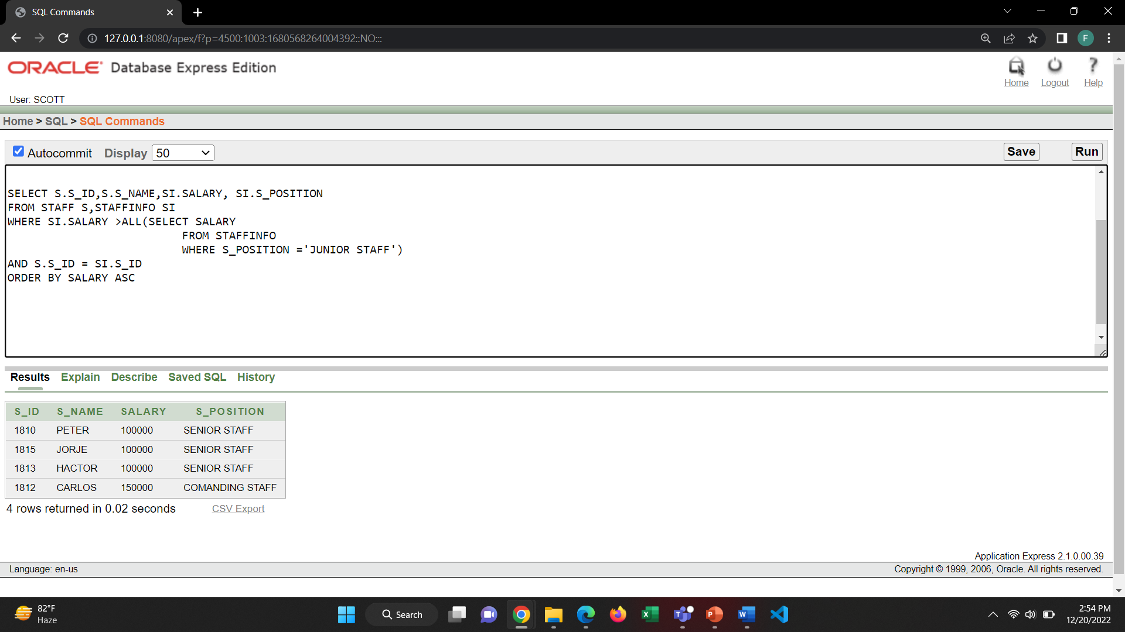2. Show the Staff ID, Name, Salary and position of those staffs who earn a salary that is higher than the salary of junior staff order by salary Ascending.

**JOINING**:

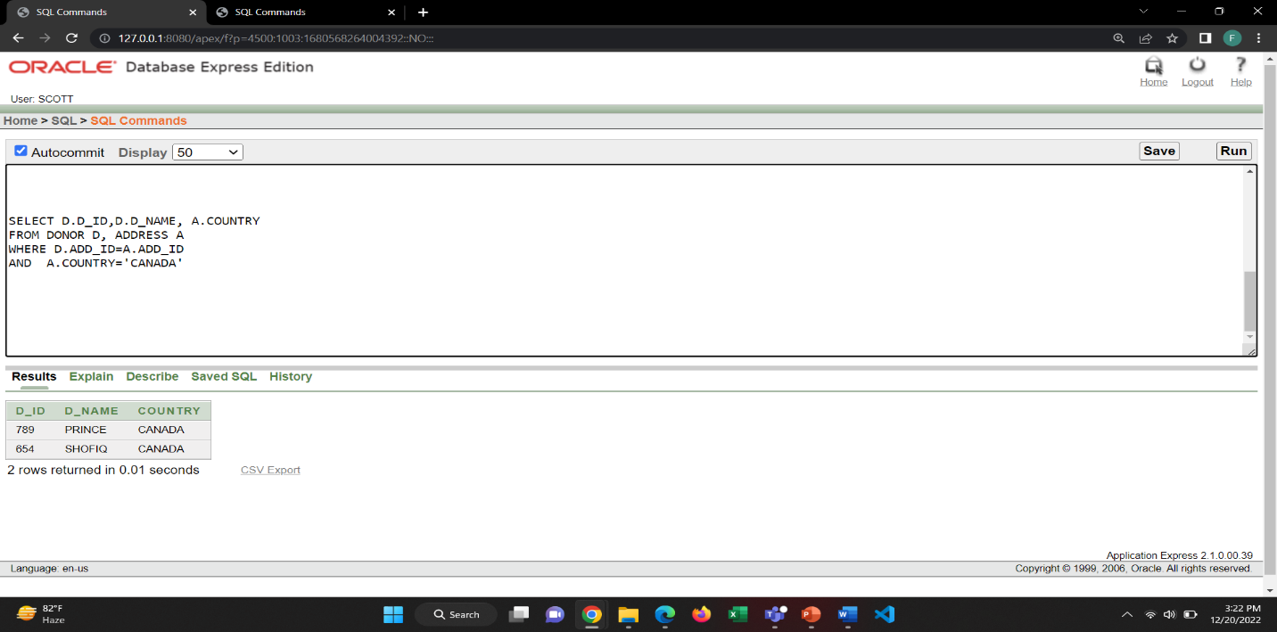1. Show the Donor ID, Donor name those are from the country CANADA.

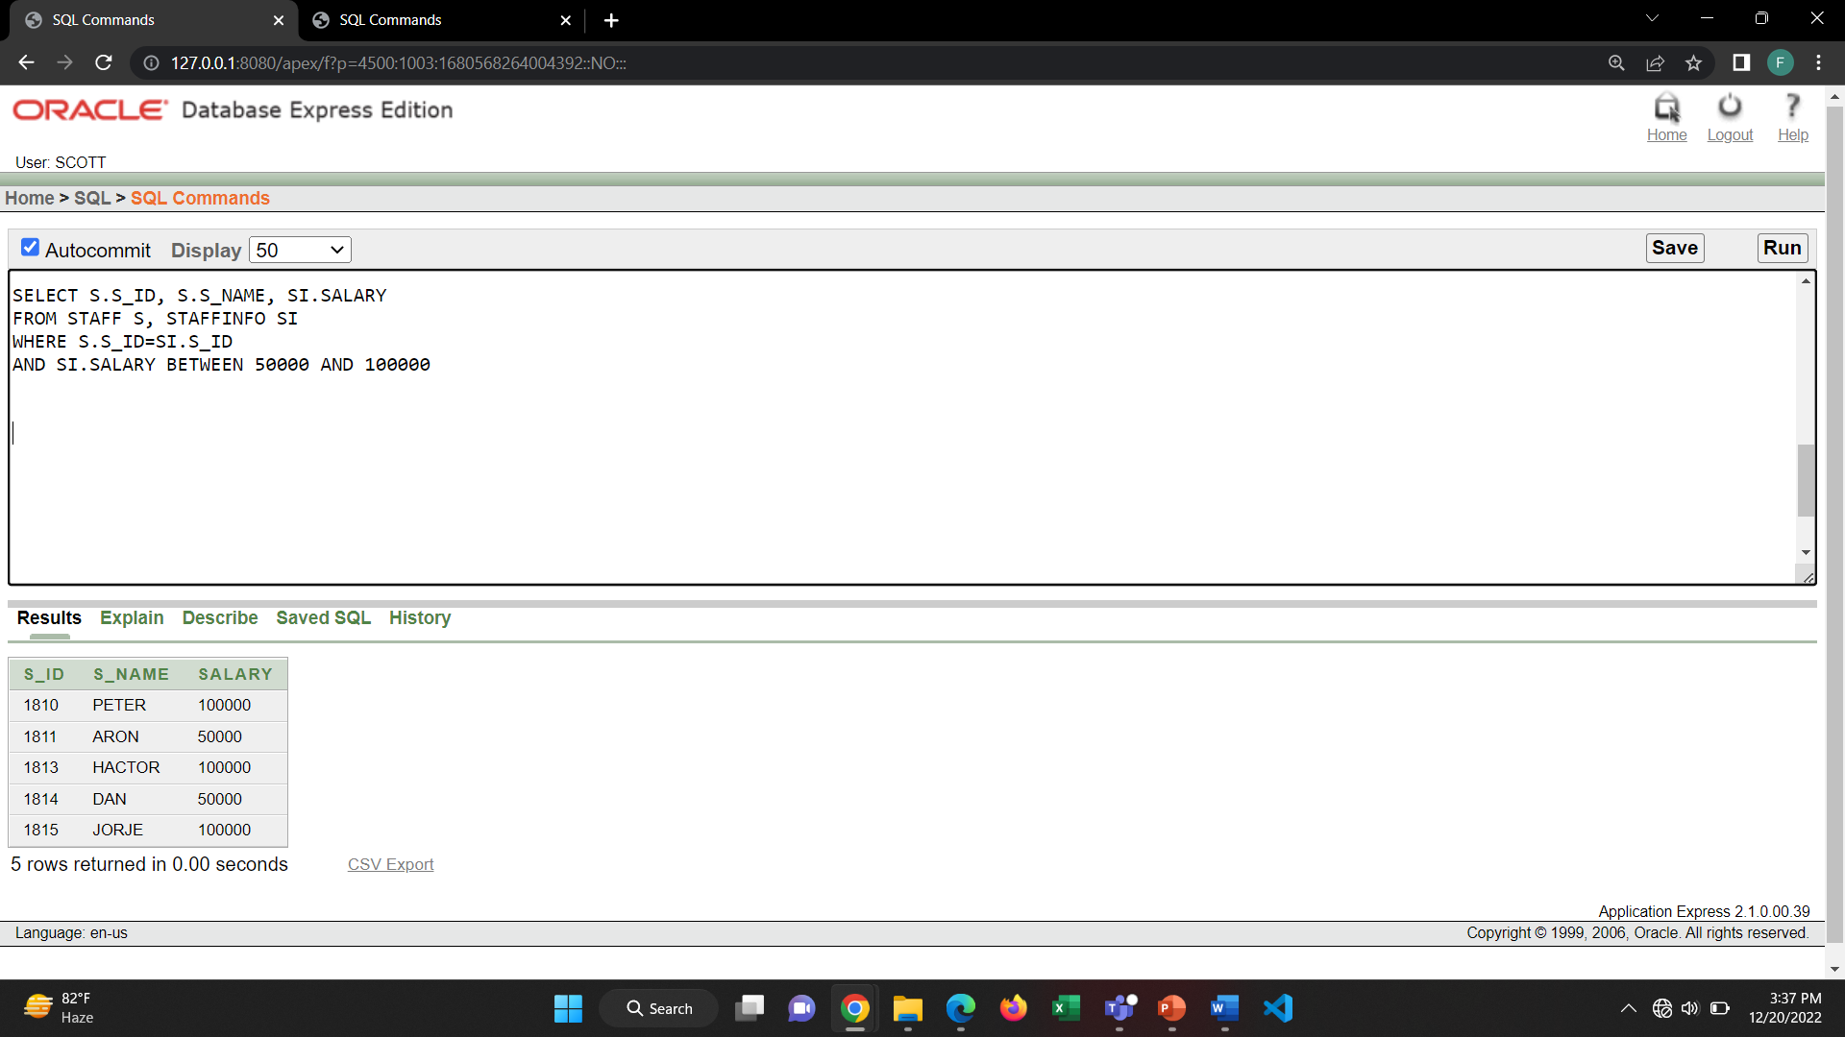2. Show Staff ID, Staff name, Staff salary where salary is between 50000 and 100000

**GROUP FUNCTION**:

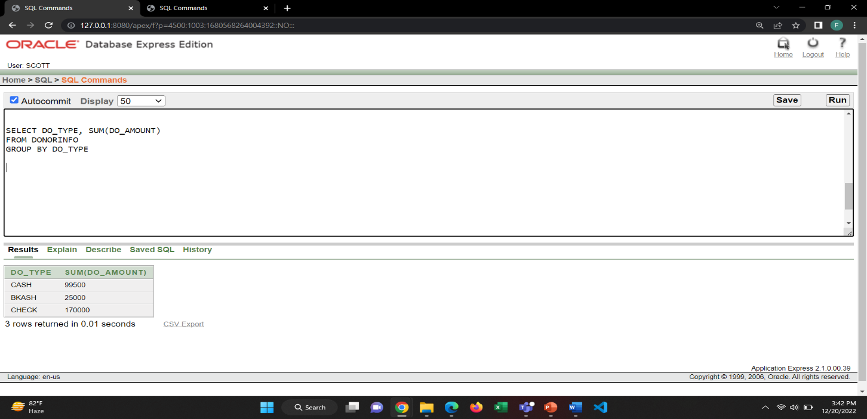1. Show the Donation Type and Sum of total donation group by Donation Type from the DONORINFO table.

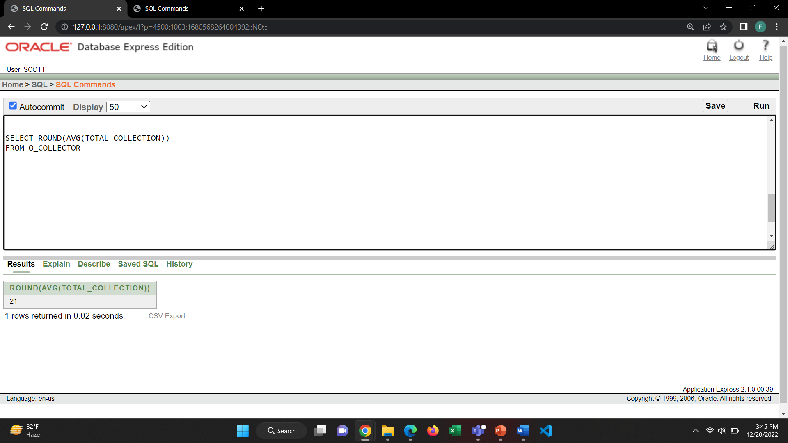2. Show the average of the total collection of the orphan collectors.

**CREATE VIEW:**

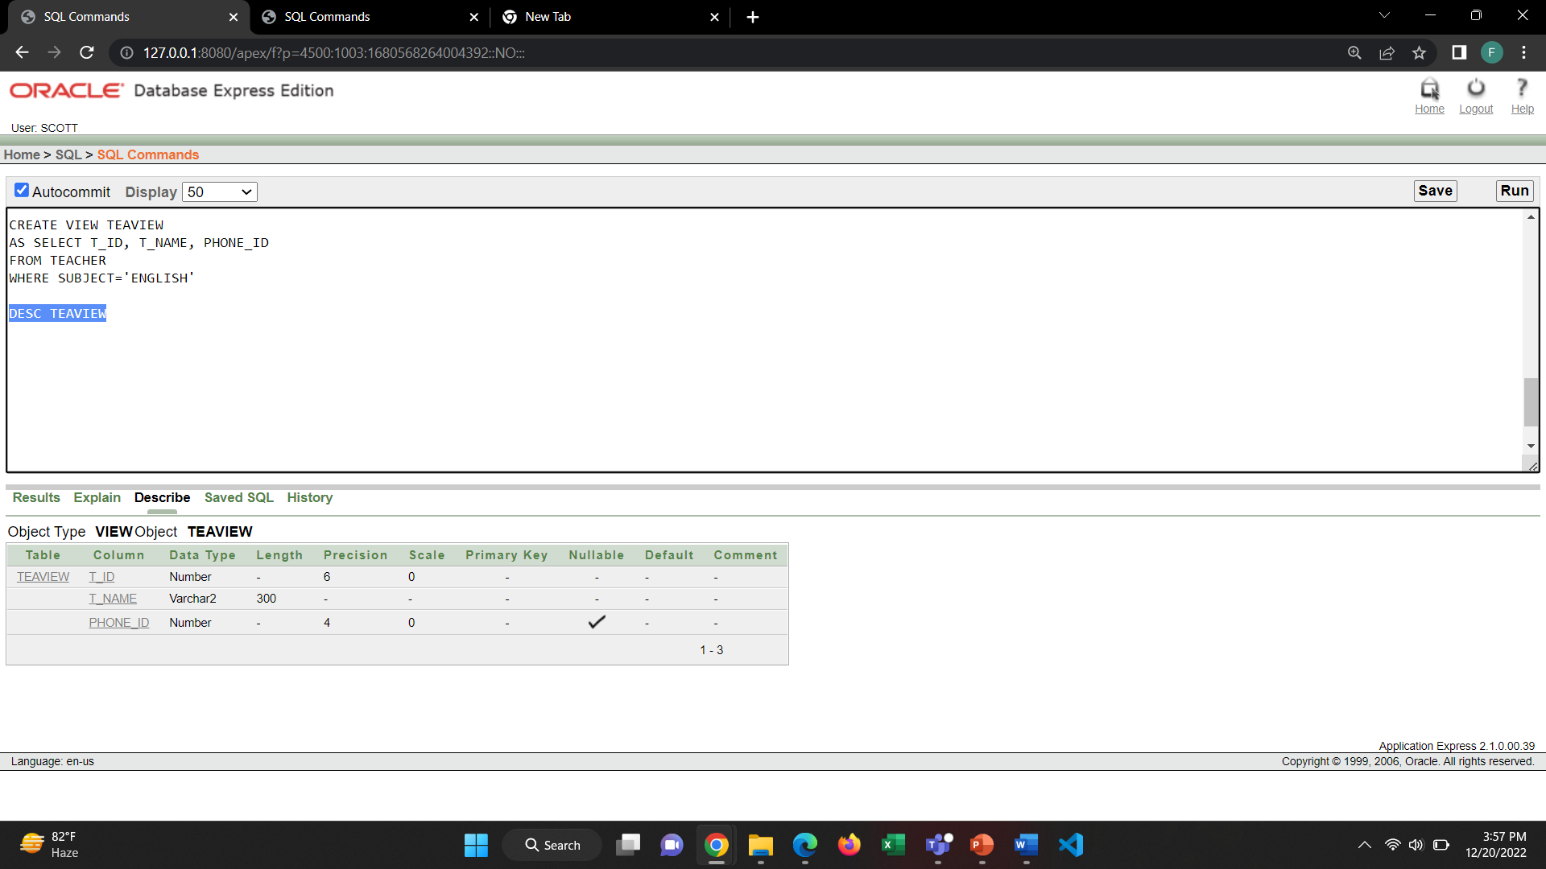1. Create a view of T_ID, T_NAME, PHONE _ID from the TEACHER table where subject is ENGLISH.

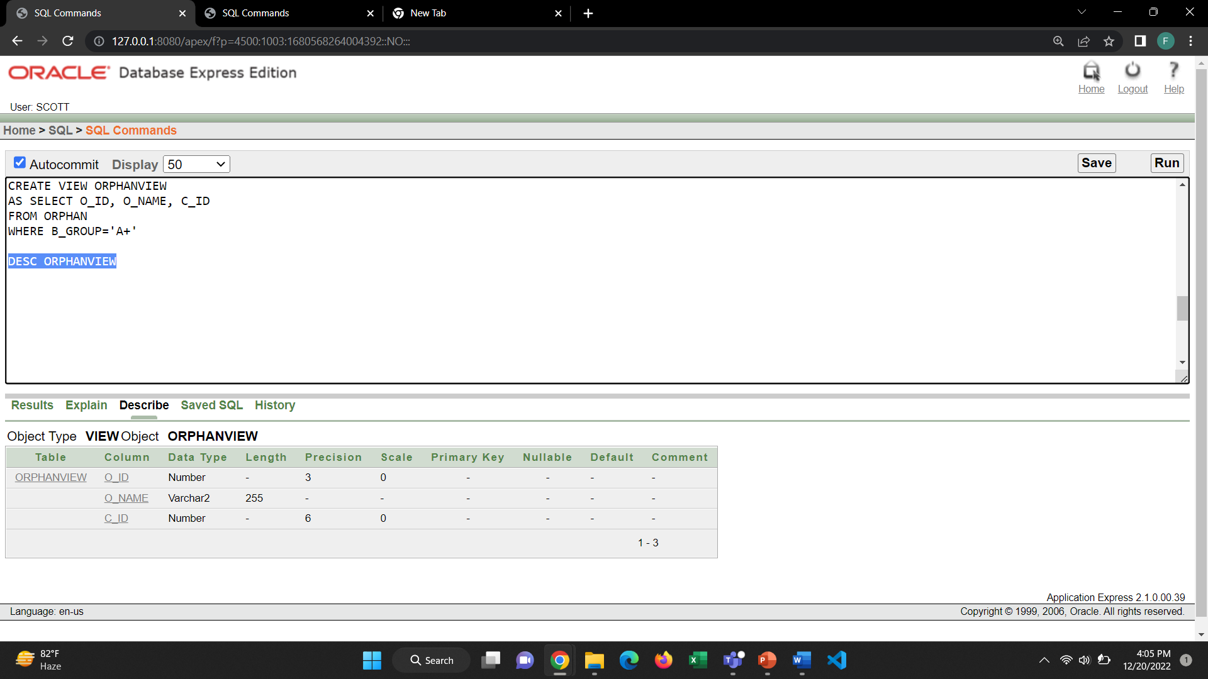2. Create a view of O_ID, O_NAME, C_ID from the orphan table where blood group is A+.

**OTHERS:**

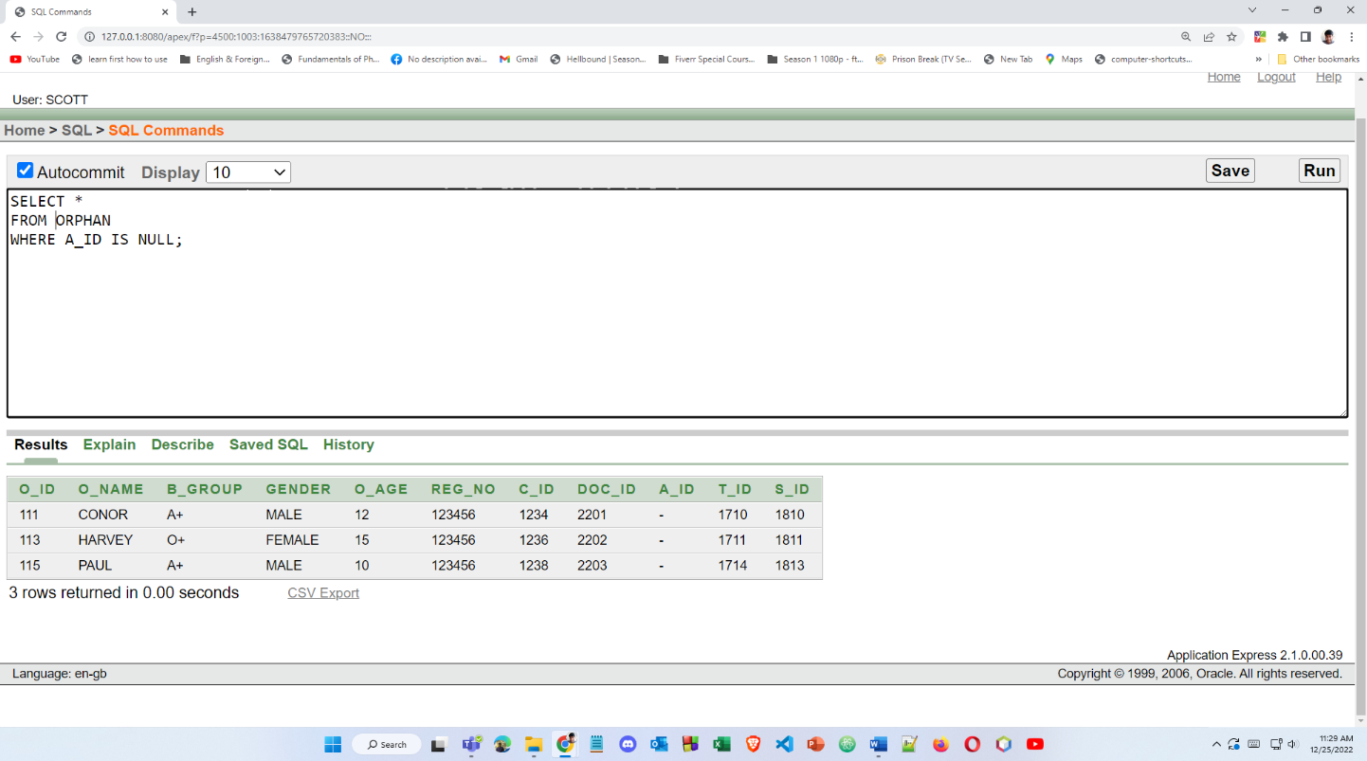1. Show the orphan info who does not have an ADOPTER.

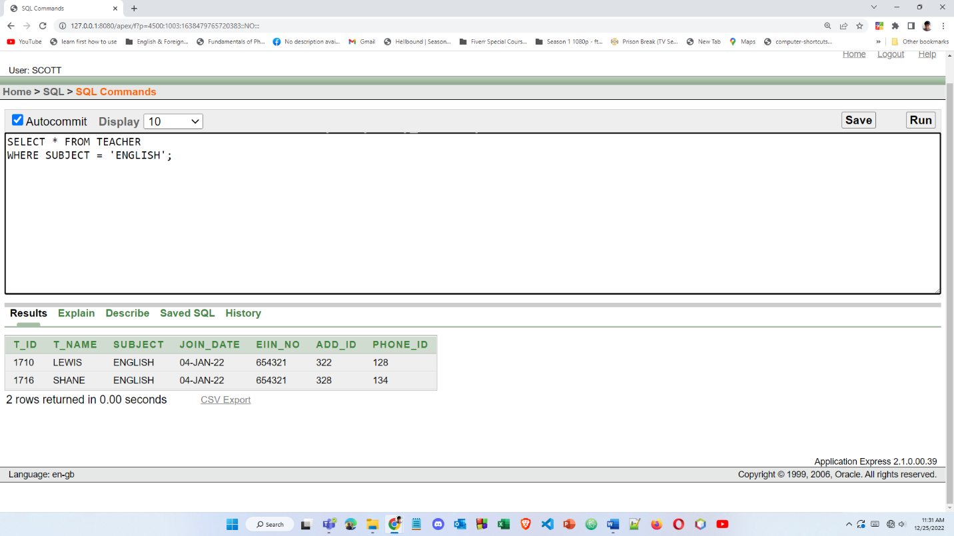2. Show the teacher info whose subject is ENGLISH.